**The Kronos Incident:**

**Geospatial-Temporal Patterns of Life**

Simran Kota and Arun Joseph

Data Science Capstone: COMP 4449

Professor Claudio Delrieux

November 20, 2022

**Introduction**

The natural gas producer, GAStech, operated a production site in Abila located on the northeast coast of the island country of Kronos. In January 2014, the company held a celebration for the release of its Initial Public Offering (IPO). This celebration by the leaders of GAStech was in response to their newfound fortune despite failing to contribute efforts toward environmental protection comparable to the company’s success.

In protest to oil and gas drilling, climate activists have turned to attacking and gluing themselves to historical and contemporary pieces of artwork including those by Vincent van Gogh and Oscar-Claude Monet (Benzine, 2022). Though climate activist groups around the world have followed suit with such practices, the level of violence was amplified in this analysis of geospatial-temporal patterns of life. The focus of the analysis revolved around the disappearance of several GAStech employees during the IPO celebration. The organization suspected of kidnapping the employees, Protectors of Kronos (POK), may have been operating as a sleeper cell within GAStech itself. As members of law enforcement, we were tasked with identifying suspicious patterns of behavior related to the disappearance of employees to make recommendations for further investigation.

There were several sources of data accessible to investigators including GPS data, car data, credit/debit card transactions, loyalty card transactions, an Abila roadmap, and the map of Abila. The GPS data involved geospatial tracking software in company vehicles broken down into four columns: timestamp, CarID, latitude and longitude. The car data showed each employee and their car designation in five columns: first and last names, CarID, as well as the current type and title of employment. The credit/debit card and loyalty card transaction data were quite similar with 5 columns each: timestamp, location, price, first name, and last name; however the loyalty transaction timestamps do not provide information pointing to the time of the day. The Abila roadmap data was provided as a shape file with point and line string data. The map of Abila was a file in JPEG format with various locations pointed out including GAStech.

The GPS data was tracked periodically for moving vehicles including company cars and trucks. Although the company cars were approved for both personal and business use, GAStech employees were not made aware of the tracking data because the company rightfully lacks trust in them. Employees without company cars were allowed to check out company trucks for business use only. Data from the day of the crime was unavailable; however, law enforcement was provided with gps, credit/debit card transaction, and loyalty card transaction data from the two weeks prior to the disappearance. Before the initial investigation began, the following assumptions were made: GAStech employees on Kronos Island were suspected members of POK, the only employees who were NOT assigned cars were truck drivers, employees do NOT share vehicles, and the provided Abila map has the names and locations of all businesses involved in the investigation.

**Data Preparation**

Although most of the provided data was fairly clean, the data types for several columns needed to be instantiated; Figures 1-4 in the appendix show a breakdown of the columns and data types for each dataset provided. The only null values present were the car data CarIDs for truck drivers, which was understood from the assumptions. In preparation for the investigation, the GPS data was merged with the car data using a left join on CarID. An example of the resulting dataset information is present in Figure 5. Then, columns with full name and date information were added to the new GPS dataset along with the loyalty and credit/debit card transaction datasets.

Next, the Abila roadmap shape file was ingested using Python’s fiona library and transformed into a pandas dataframe with line and point strings separated. The data with the line strings was loaded into a json format and then converted into a geopandas geodataframe for ease of plotting. The .jpg file containing the map of Abila was ingested using a matplotlib.pyplot function. Both ingestion processes are demonstrated in Figure 6 and the overlay of the roadmap on the map of Abila is shown in Figure 7.

Following ingestion, credit/debit card and loyalty card transaction data were concatenated into one transaction dataset and is shown in Figure 8. An extra label column was added to signify each transaction as either a credit or loyalty card transaction and the time of day timestamp for loyalty transactions was set to midnight. Figure 9 shows a cross-sectional dataset of grouped transactions which was created to reflect the total transactions placed by each employee at each location on any given day. Also, a more general dataset was created from the transaction and car data to reflect the total transaction value spent by each employee in the 2 weeks worth of data and is displayed in Figure 10. Several additional dataset manipulations were conducted to gain an overall understanding prior to initial investigation; these included categorizing GPS data into 3 different times of the day (‘Morning’, ‘Working’, and ‘Evening’ hours) and grouping the number of people who made transactions at each location by date. Morning was defined as anything before 7:00 am, evening was defined as anything after 5:00 pm, and anything in between was considered working hours. Weekends were timestamps from the four weekend dates included in the data.

Upon examination of Figure 10, we can see that the top 9 employees with the highest total transaction values in this 2 week dataset were truck drivers. Additionally, the GPS data includes 5 vehicle CarIDs which were not assigned to any employees and were assumed to be rented out company trucks and considered “unmarked cars”. Figure 11 is a dataset involving truck driver transactions placed on 1/06/2014 andFigure 12 is an example of unmarked car routes tracked on 1/06/2014 and plotted on the map of Abila. By spot checking truck driver transactions and matching them to unmarked car routes tracked on the same respective dates, trucks were matched to the appropriate employees on the specific days that each rental was made. The resulting formulated assignments are present in Figure 13. From this information we were able to learn that each truck driver had at least one truck rental and Valeria Morlun & Henk Mies were the only truck drivers to drive their own vehicles. We were also able to pinpoint two significant locations where truck driver transactions were made but were not marked on the map of Abila. These locations are distinguished in Figure 14. From these findings, we were able to re-evaluate the prior assumptions that were made: employees do in fact share vehicles (as evident from the truck vehicle assignments) and the provided Abila map may not have all the locations and businesses relevant to the investigation.

**Identifying Normal Behavioural Patterns**

Our first task was to identify what a normal day in the life of a GAStech employee looks like so that we may better identify deviations from the usual behaviors. In order to do this, we leveraged a combination of the employee to car mappings, GPS data, and Abila route data to construct maps of the employees’ daily routes. Figure 15 is an example of one such map that shows daily employee routes on January 15, 2014. What we saw was that a typical day for a GAStech employee consisted of driving from their home to the GAStech facility, stopping at one or more coffee shops during the course of their day, and driving to other locations around the island regularly as needed.

**Identifying Strange Behaviors**

Once we had established what the employees’ normal behaviors looked like, we were able to dig deeper to find unusual variations from that behavior. We compared routes of each individual employee day over day, transactions at each location on the island across all employees, and cross referenced GPS data with said transaction data. As a result of our analysis we were able to point out 12 patterns which stood out to us that warrant further investigation.

*Pattern 1: There were identical charges for Elsa Orilla and Kanon Herrero at Kalami Kafenion on 1/7 and Ahaggo Museum on 1/18.*

Two employees of GAStech, Elsa Orilla and Kanon Herrero, were recorded on two separate instances as having transactions at the same location on the same date for the same amount (Figure 16). Each of these pairs of transactions consisted of one loyalty transaction recorded on Elsa’s card, and one credit/debit transaction recorded on Kanon’s card. Although the timestamp for all loyalty transactions were set to midnight on the day of the transaction, our GPS data suggests that these two employees were at the same location around the timestamp on the credit transaction. We were not provided with any location info for Kalami Kafenion, so we cannot confirm whether or not the two were actually present at the location at the time of the transactions even if they were together (Figure 17). However, they were both recorded at the same coordinates 4 minutes after the transaction occurred which warranted suspicion. For the second transaction at Ahaggo Museum, we saw evidence of the two visiting on 1/18, but only 4 hours *after* the transaction was recorded (Figure 18). This was the first piece of GPS data recorded for either of them after the time of the transaction (Figure 19). These findings revealed an unexpected level of closeness between these two employees suggesting they were traveling together and sharing transactions, and begs the question: what is the nature of their relationship?

*Pattern 2: Truck drivers visited the same unmarked locations and were involved in large transactions.*

The transactions that took place at 2 of the unmarked locations on the map (Stewart and Sons Fabrication and Kronos Pipe and Irrigation) appeared unusually high. Figure 20 shows several of the transactions that were made at the first location. Both Cecilia Morluniau and Adan Morlun made credit card transactions of over $4500 within 30 minutes of each other on 1/15. On 1/10, Cecilia again shared similar large transactions over $4000 with Claudio Hawelon at this same location. Then looking at truck driver transactions placed on 1/9, Cecilia made another large transaction worth over $3500 at Stewart and Sons Fabrication while both Benito Hawelon and Dylan Scozzese did as well. The aforementioned transactions on 1/9 and 1/10 were loyalty card transactions therefore the times of these transactions were not available however the date and place of these transactions in connection to Cecilia Morluniau were significant. The other unmarked location that was interesting to investigate was Kronos Pipe and Irrigation. As shown in Figure 21, transactions at this location range from around $240 to over $3900 and are made by only 2 truck drivers: Albina Hafon and Irene Nant. These two employees seem to never work on the same day. Looking closely at their transactions throughout the course of the 2 week data, there is only one credit card transaction made at Kronos Pipe and Irrigation on 1/13. Coincidentally out of the 7 days that either of them rent out a company truck, Albina fails to make a transaction here on 1\14 which is exactly one day after she made her one and only credit card transaction at this same location. Considering the transactions made at Kronos Pipe and Irrigation and Stewart and Sons Fabrication were unusually large compared to many of the transactions of the other employees, the level of confidence about this pattern was quite strong.

*Pattern 3: Truck drivers repeat large transactions with loyalty cards at locations of interest.*

The truck driver transaction location value counts is displayed in Figure 22 and includes the 2 previously unmarked locations. One pattern that was recognized at some of these locations of interest was the fact that numerous transactions, mostly those large in value, repeat on the same day and appear as loyalty card transactions (Figure 23). Due to the lack of domain knowledge introduced to investigators, it was hard to determine whether loyalty card transactions that occur alone or those paired with credit card transactions were considered suspicious since both scenarios were witnessed in this analysis. However, the combination of the places (Abila Airport, Nationwide Refinery, Stewart and Sons Fabrication, and Kronos Pipe and Irrigation), the individuals, and the large prices involved in such transactions distinguished the pattern as significant. Also, individuals connected to each other through the previous pattern were once again involved in these transactions and include Claudio Hawelon, Albina Hafon, Adan Morlun, Benito Hawelon, Dylan Scozzese, and Cecilia Morluniau. With these individuals and their similarities in mind, the level of confidence about this pattern was high since this was the second pattern shared amongst them.

*Pattern 4: Brand and Isande had recurring purchases at the hotel on the same dates.*

By digging deeper into the transactions made at the Chostus Hotel, we saw that the majority of transactions were conducted by employees Brand Tempestad and Isande Borrasca, and there seemed to be a large overlap in transactions between the two (Figure 24). In order to confirm their behavior, we checked their GPS data on 1/17 – one of the dates they both had transactions recorded at the hotel – and we found that it confirmed that both were, in fact, present at the hotel during these transactions (Figure 25). As residents of Abila, this once again begs the question of why these employees were regularly visiting a hotel. Confidence about this pattern being significant was high, especially since the presence and transactions of both Brand and Isande at the hotel occur on the same days.

*Pattern 5: Cecilia and Irene shared transactions with other truck drivers on dates they did not have vehicles designated to them.*

Since trucks were shared among the truck drivers on different days, based on transactions alone it was difficult to clarify whether the same trucks were ever shared between drivers on the SAME day. Through careful inspection, we were able to discover 2 dates in which there were more truck drivers making transactions than there were company trucks that were used. Looking at Figure 26 and cross referencing the truck assignments on Figure 13, we concluded that Cecilia Morluniau was making transactions on 1/9 despite lacking a truck rental. Additionally, she shares transactions at certain locations of interest such as Stewart and Sons Fabrication and Nationwide Refinery with other truck drivers including Benito Hawelon, Dylan Scozzese, and Valeria Morlun; however since many of the transactions were made with loyalty cards, the lack of time data assumes that such transactions may be connected. Then looking at Figure 27 and cross referencing the truck assignments for 1/10, Irene Nant’s $3489.36 transaction at Carlyle Chemical Inc. can be isolated as the only transaction on that day made by a truck driver without a truck rental. Although Claudio Hawelon shares only a $227.81 loyalty transaction at the same location, Irene’s transaction was suspiciously large and therefore marked Claudio for suspicion as well. Since Cecilia, Benito, Dylan, Claudio, and Irene were already called out on previous patterns, the level of confidence about this pattern is quite high.

*Pattern 6: Many employees seem to be at GAStech after hours*

In investigating the overall route patterns for GAStech employees, we were especially interested in where employees were spending their non-working hours. To do this, we first plotted a map of all locations that had GPS data for more than 2 employees recorded outside of working hours (Figure 28). Upon doing so, it was immediately obvious that quite a few employees were present at GAStech after working hours. By digging into the GPS data to see exactly who was present, we saw employees from all across the company, ranging from leadership to security. We also see one unmarked car present, indicating that a truck driver might have been present as well (Figure 29). This raises the obvious question of why so many employees are at the facility after hours. As groups of employees present at the company with each other or individually, both situations raise red flags with medium to high confidence in this pattern’s significance.

*Pattern 7: Two employees are in a residential area above Carnero St in the early morning hours.*

In looking at locations where GPS data was recorded for pairs of employees outside working hours, we identified the residential area above Carnero St as a location of interest (Figure 30). By drilling into our GPS data for that location, we saw two employees, Onda Marin and Balas Felix, that were together at the same coordinates a little after midnight (Figure 31). This is very late/early for two employees to be together, indicating some sort of relationship beyond coworkers between the two. Although out of the ordinary, the confidence in significance of this pattern in relation to the disappearance is low to medium.

*Pattern 8: 2 employees were together at the Capitol on the weekend*

From Figure 30, we also saw evidence of two employees visiting the Capitol on the weekend. By digging into the GPS data around those coordinates, we saw evidence of four employees visiting the Capitol on a weekend in our two weeks of data (Figure 32). Of the four employees, however, only two were of interest as their timestamps were quite close to each other. The first two employees, Kanon Herrero and Adra Nubarron, visited quite a bit before the other two, and at separate times. The last two employees who visited, Loreto Bodrogi and Edvard Vann, both visited a little after 1:00 pm on January 18th, which indicates that they might have been visiting together. However, it is quite strange for employees to visit government buildings together, which begs the question of whether they were simply there for leisure, or some ulterior motive. In either case, this pattern garnered low to medium confidence in its significance to the disappearance.

*Pattern 9: Employees frequently visit the hotel on the same dates*

We decided to dig into the hotel a little more as it appeared in quite a few employees’ route data; as a result we found that this location appeared to be frequented by the employees of GAStech on a regular basis. An example day’s GPS data is included in Figure 33 which has 6 employees present at the Chostus Hotel on the same date, and this occurs more than once. However, we cross referenced this with our transaction data and found that most of these employees, with the exception of Brand, Isande, and Sten, don’t have transactions at the hotel (Figure 34). Since the other employees were present at the hotel but were not making any purchases, it seemed to indicate that they were meeting someone there, but it is highly unlikely that each employee was meeting a different person. The most logical conclusion is that they were there to meet each other and have a private discussion at a neutral location. We have very high confidence in the significance of this pattern.

*Pattern 10: Loreto Bedrogi and Felix Balas are the only ones with GPS data at the scrapyard but all transactions are under Dylan Scozzese’s name.*

One of the locations of interest to us was the scrapyard as we would only see a few data points indicating that employees were visiting that location. By drilling into those specific coordinates, we saw that Felix Balas and Loreto Bodrogi were the only employees with company cars to visit Abila Scrapyard (Figure 35). However, we again cross referenced this with the transactions at the scrapyard, and to our surprise neither of these employees had any transactions at this location. According to Figure 36, Dylan Scozzese was the only employee with any transactions at the Abila Scrapyard. There were only a few possible explanations for this. It’s possible that Felix and Loreto were using Dylan’s loyalty account or Dylan was a passenger with them when they visited the scrapyard. Both scenarios were indicative of a deeper relationship between the three employees. The simple fact that Felix and Loreto visited the scrapyard without making any purchases gives us high confidence in the significance of this pattern.

*Pattern 11: There are groups of employees who meet regularly at coffee shops. One person takes turns paying each day.*

Since the employees of GAStech seemed to frequently visit coffee shops as part of their daily routes, we decided to look at these a little closer and verify whether there was any associated suspicious behavior. One of the coffee shops, Bean There Done That, was quite popular and frequently visited by multiple employees each day (Figure 37). In looking at the timestamps and employee information for who was visiting, nothing unusual is immediately obvious as these visits tended to occur in the early morning hours of the workday (Figure 38). However, when cross referencing that information with the transaction data, we saw that there were unusually large transactions occurring at the coffee shop by those employees (Figure 39). Such transactions were more than $90 and occurred once a day. It is very difficult to spend that large of an amount at a coffee shop unless many individual items are being purchased, indicating that these seemingly normal visits may have actually been some sort of group meeting.

We saw a similar behavior at Brew’ve Been Served, where there were one or two very large ($90 or more) transactions a day by individuals (Figure 40). By cross referencing this with GPS data, we saw that this was a very popular location for employees (Figure 41), but not all employees were present at the same time (Figure 42). However, a subset of 8 employees did seem to be present around the same time, and these were in the late evening – a very unusual time to visit a coffee shop. This subset also included the employees who were recorded as making unusually large purchases earlier in the day. Again, this points towards the coffee shop being an organized meeting location for these employees as opposed to a casual stop in their day to day activities. Similar to the hotel, the presence of multiple employees at the coffee shops on the same dates provides strong confidence in the significance of this pattern to the disappearance.

*Pattern 12: Elsa Orilla never goes to GAStech.*

Elsa Orilla was a person of interest from the beginning due to her unusual relationship with Kanon Herrero and her strange route patterns (Figure 43). Every single day’s GPS data for her was sporadic and cyclical, indicating some sort of defect or malfunction with her car’s sensor that was not observed on any other unit. To dig deeper, we attempted to smooth the data by taking a rolling average of her recorded coordinates as the median of the previous ten recordings. While this did significantly reduce the noise in the dataset, it also pointed out a very unusual pattern – not once in the two weeks of recorded GPS data did Elsa Orilla ever visit the GAStech facility (Figure 44). As an employee of a company it is reasonable to expect regular, or even infrequent, visits to their place of employment, but for Elsa Orilla there is not a single record of this. The available GPS data on her car during working hours illustrates that she only drove around 8am and between 12-2pm. This is very strange behavior worth further investigation to determine whether her lack of presence at the building is company sanctioned “work from home” or indeed suspect behavior. The confidence level of this pattern being significant is high; further investigation would help determine Elsa’s involvement in the disappearance.

**Conclusion**

Through our investigation of the data we learned that our initial assumptions could not be trusted. Not only were truck drivers sharing vehicles, but there were also locations where transactions were taking place which did not exist on the map that was originally provided. When identifying behavioral patterns of the employees, several names seem to stand out consistently; however this task was proven to be arduous with the lack of domain knowledge on the employees, their responsibilities, and their relationships. Any individual pattern can be justified yet from an outside perspective, the GAStech employees as a whole behave quite strangely.

While two weeks of data seems large, trying to piece together patterns for a big picture investigation was quite difficult because we struggled to distinguish between strange and normal behavior among groups and individuals. Further investigation requires more data such as airport logs of people and materials leaving and entering Abila, employee personal vehicle data, and company vehicle tracking data going back further than just 2 weeks. Additionally, transaction data on the local population may help distinguish strange transactions made by the employees which would be uncharacteristic of the general population of Abila. Also, an inventory log of truck deliveries including transport material, time, location, and driver information would be extremely beneficial in discerning erratic behaviors amongst the truck drivers. We recommend investigators dig deeper into the employees of GAStech with the suggested supplementary information because we are confident the patterns are evidence that the disappearance is more than likely an inside job.

**Bibliography**

Benzine, V. (2022, October 31). *Here is every artwork attacked by climate activists this year, from the 'Mona Lisa' to 'girl with a pearl earring'*. Artnet News. Retrieved November 18, 2022, from https://news.artnet.com/art-world/here-is-every-artwork-attacked-by-climate-activists-this-year-from-the-mona-lisa-to-girl-with-a-pearl-earring-2200804

**Appendix**

*Figure 1. GPS dataset data types*

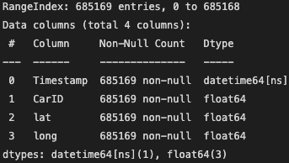

*Figure 2. Car dataset data types*

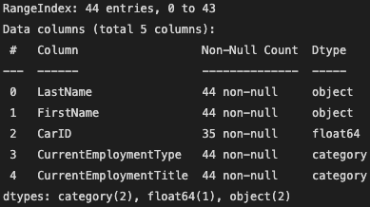

*Figure 3. Credit/debit dataset data types*

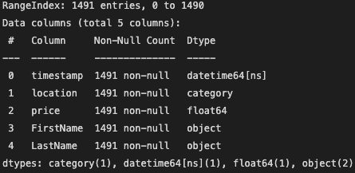

*Figure 4. Loyalty card transaction dataset data types*

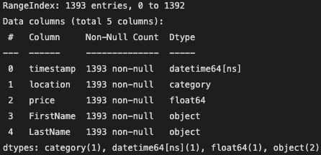

*Figure 5. GPS & car datasets merge result*

**

*Figure 6. Shape & .jpg file ingestion*

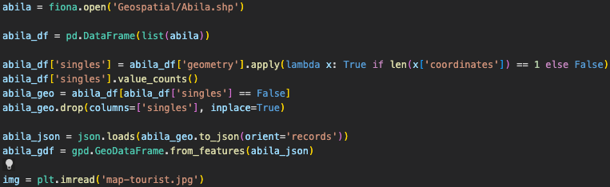

*Figure 7. Abila roadmap overlay on map of Abila*

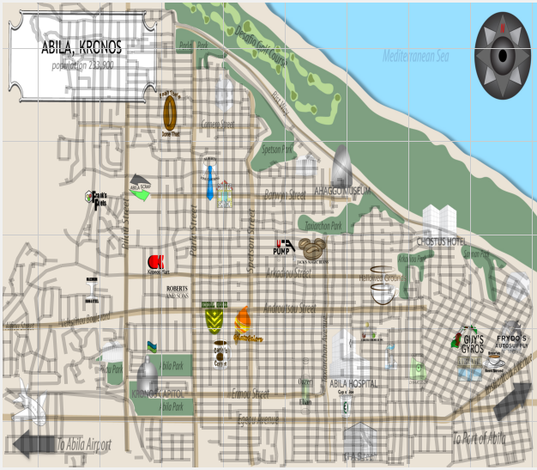

*Figure 8. Transaction dataset*

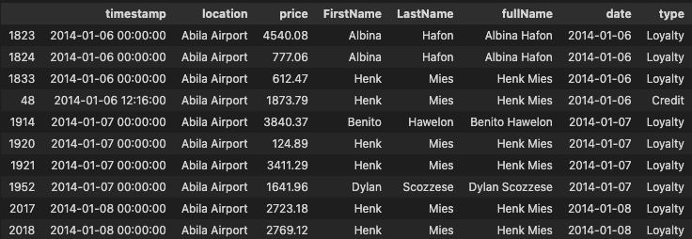

*Figure 9. Grouped Transactions dataset*

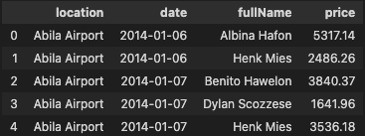

*Figure 10. Dataset of top 15 employees by total transaction value*

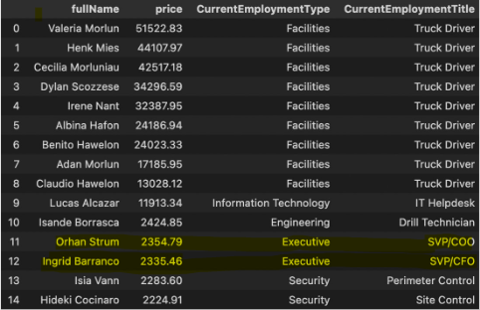

*Figure 11. Dataset of truck driver transactions placed on 1/06/2014*

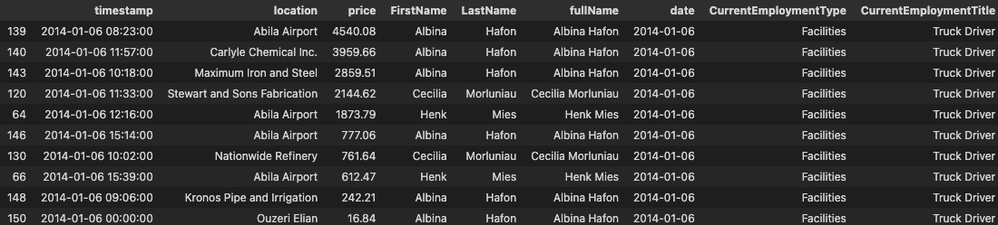

*Figure 12. Plot of unmarked car routes tracked on 1/06/2014*

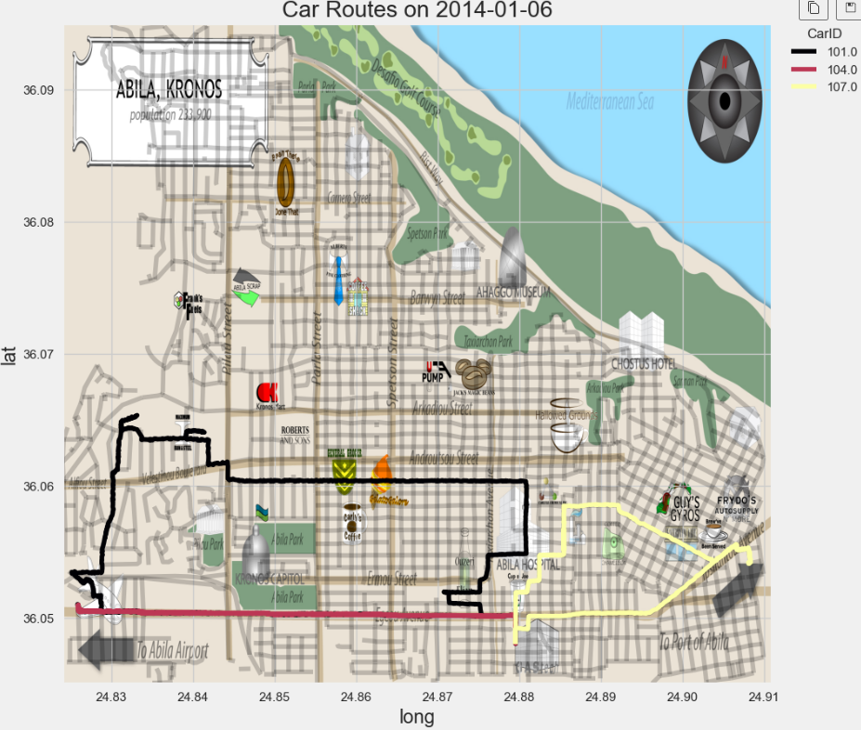

*Figure 13. Unmarked car assignments*

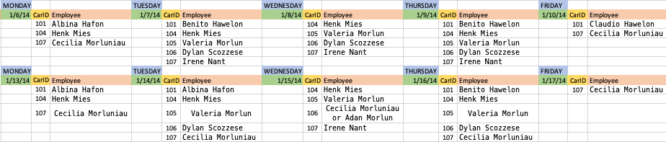

*Figure 14. Map of Abila with two new significant locations*

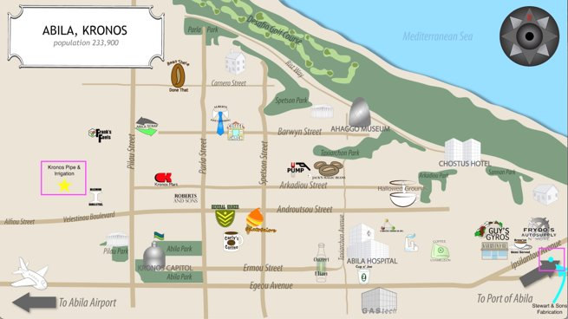

*Figure 15. Daily Routes of Employees on 1/15/14*

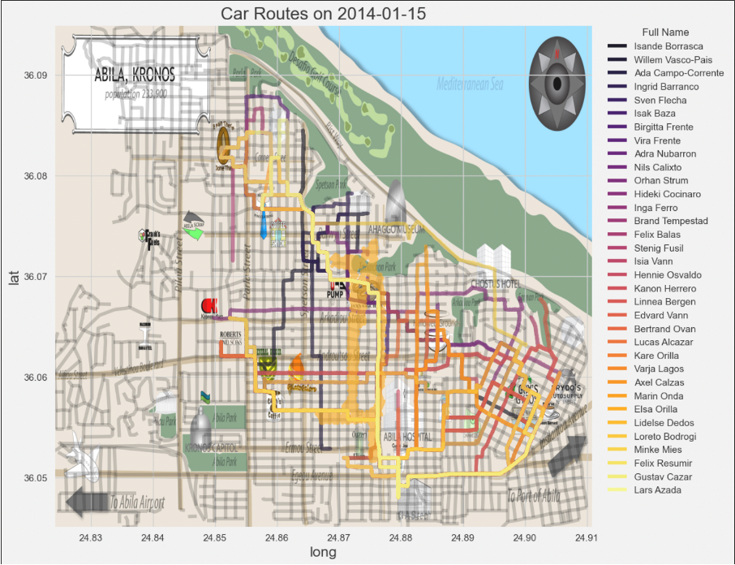

*Figure 16. Identical Transactions for Elsa Orilla and Kanon Herrero*

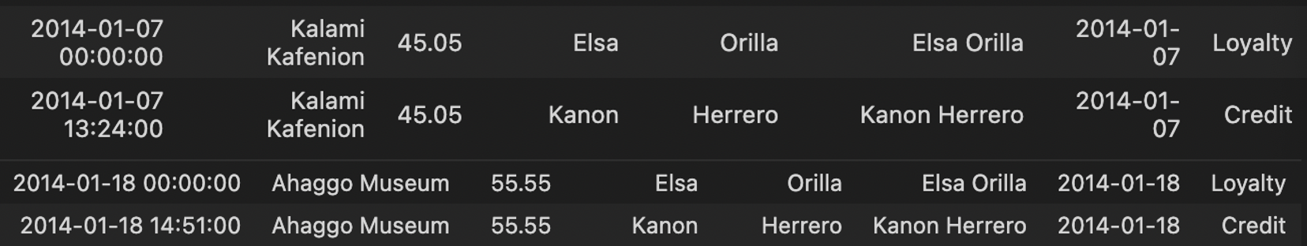

*Figure 17. GPS data of Elsa Orilla and Kanon Herrero on day of Kalami Kafenion transactions*

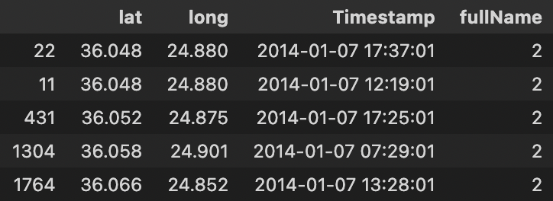

*Figure 18. GPS data of Elsa Orilla and Kanon Herrero on day of Ahaggo Museum transactions*

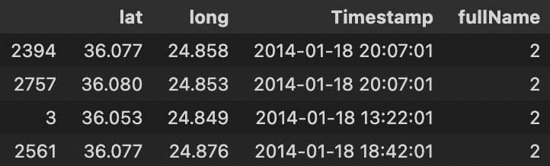

*Figure 19. GPS data of Elsa Orilla and Kanon Herrero after Ahaggo Museum transaction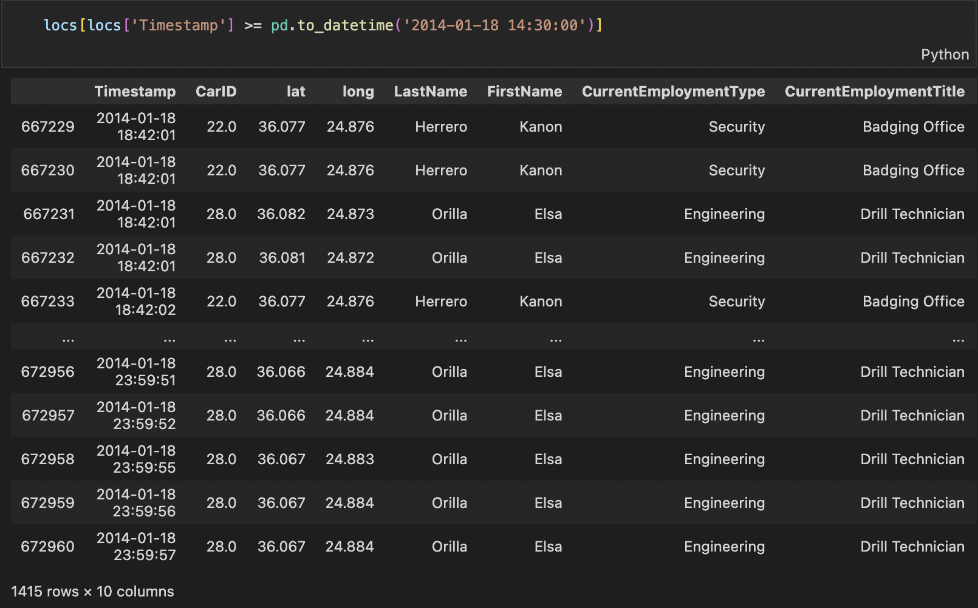*

*Figure 20. Transactions at Stewart and Sons Fabrication*

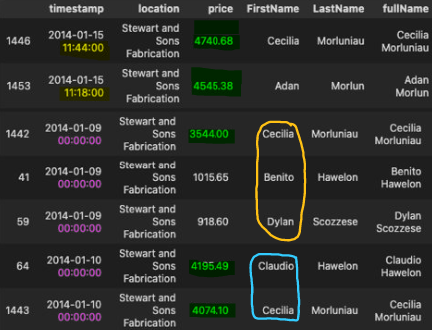

*Figure 21. Transactions at Kronos Pipe and Irrigation*

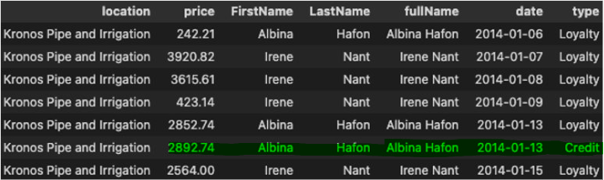

*Figure 22. Truck driver transaction location value counts*

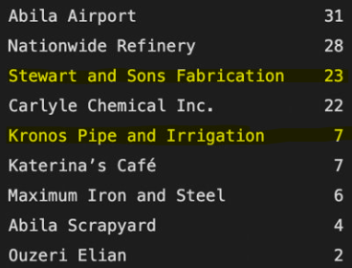

*Figure 23. Repeat loyalty card truck driver transactions at locations of interest*

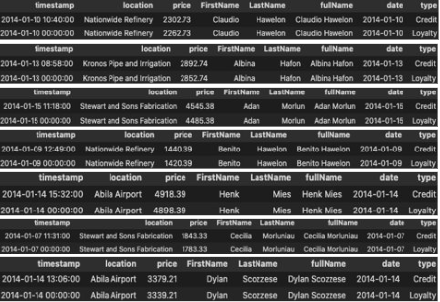

*Figure 24. Transactions at the Chostus Hotel by Brand and Isande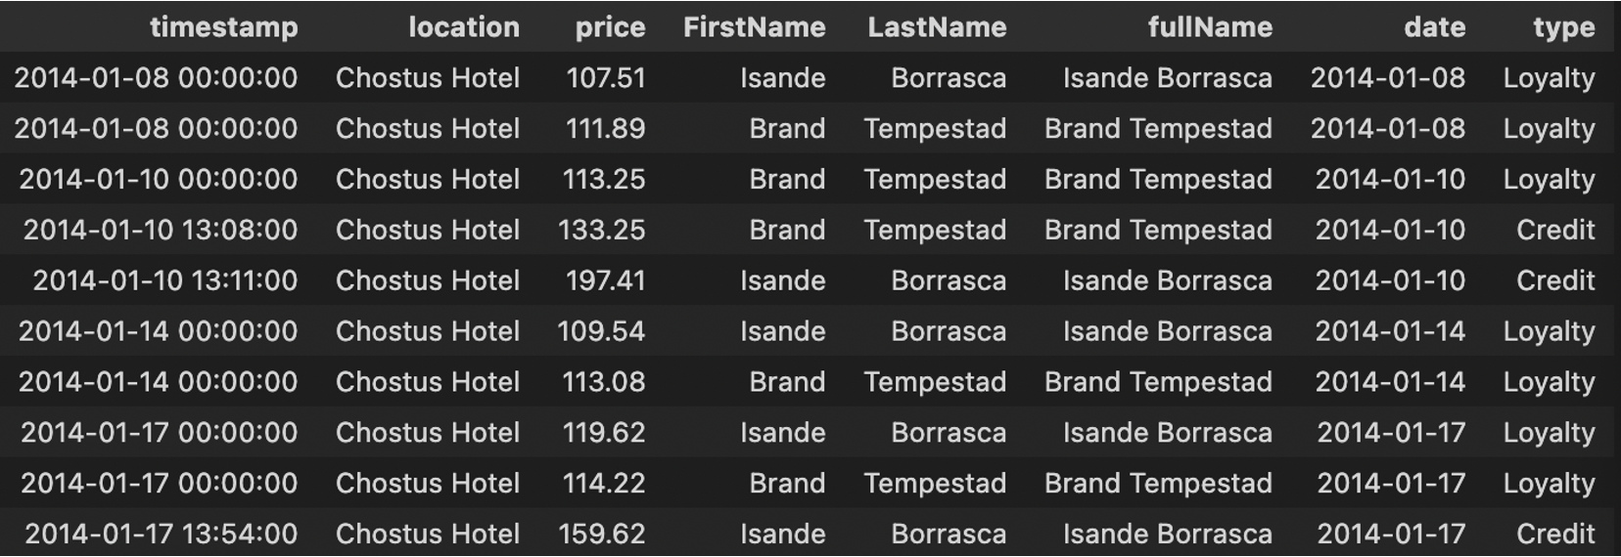*

*Figure 25. GPS data of Brand and Isande on 1/17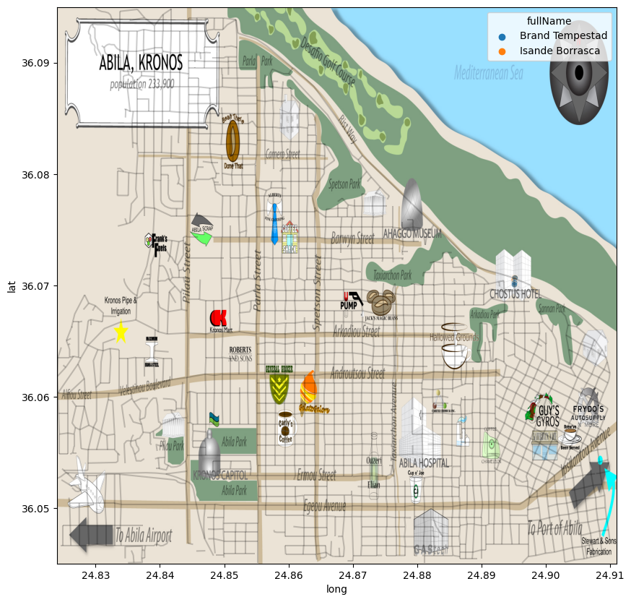*

*Figure 26. Truck driver transactions on 1/9*

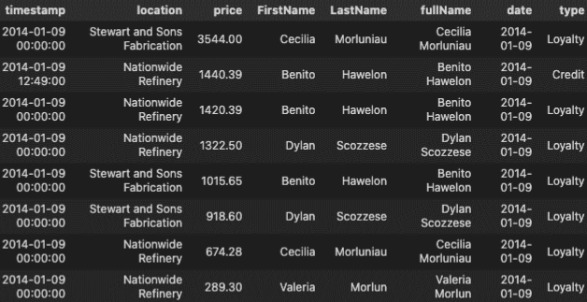

*Figure 27. Truck driver transactions on 1/10*

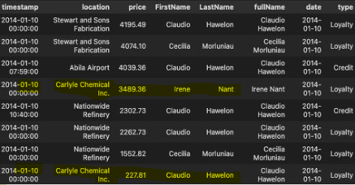

*Figure 28. Locations with more than 2 employees*

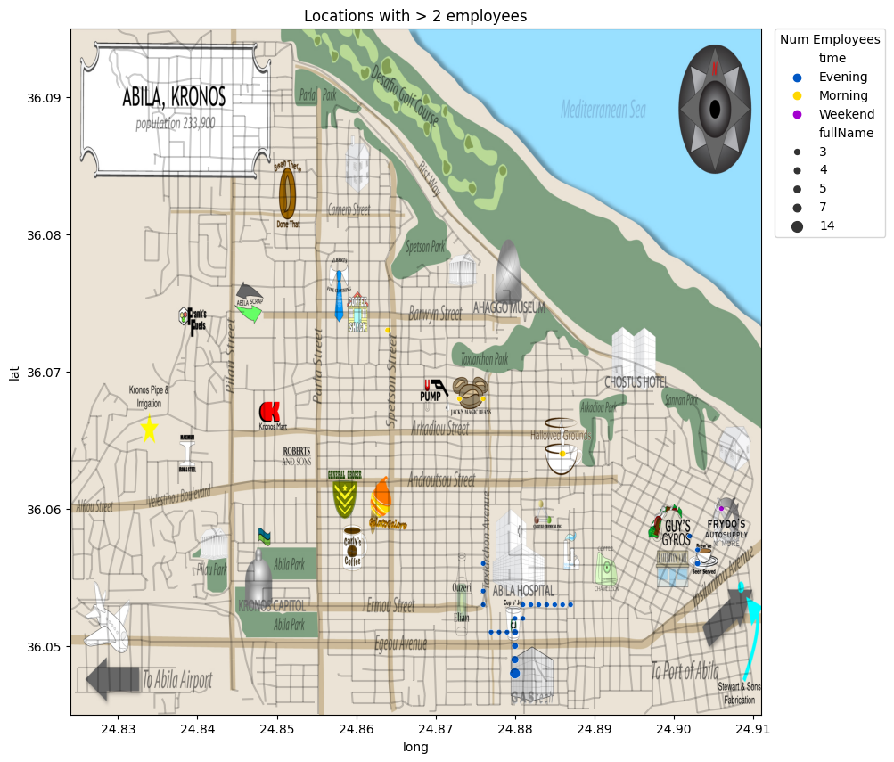

*Figure 29. Employees present at GAStech after working hours*

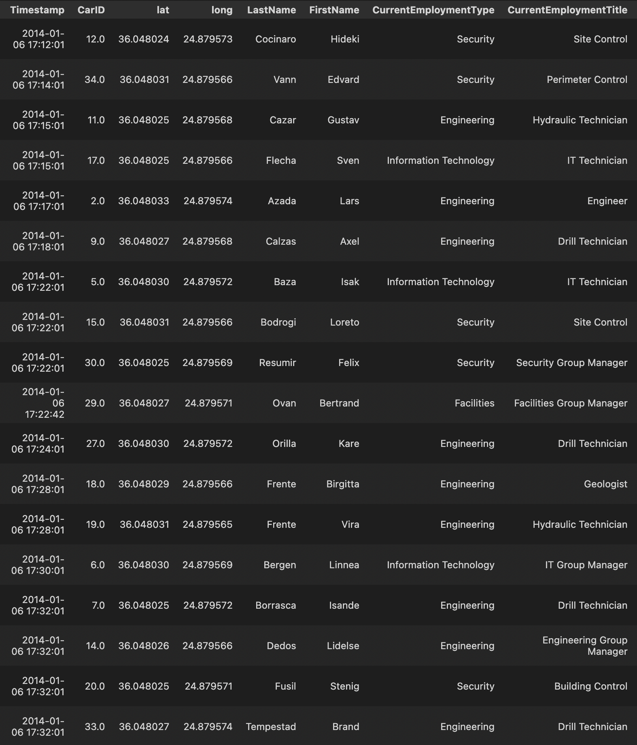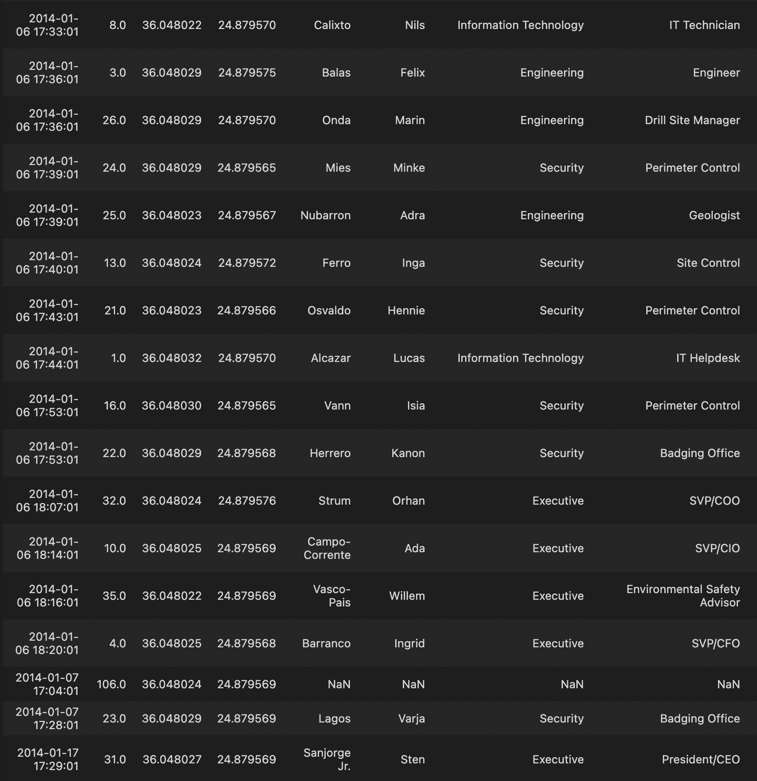

*Figure 30. Locations with 2 employees distinguished by time of day*

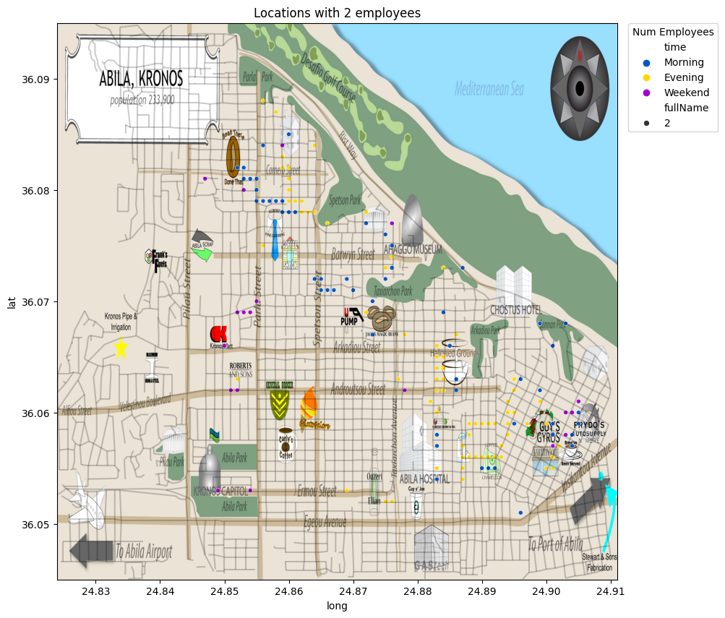

*Figure 31. GPS data at Carnero St*

**

*Figure 32. Weekend visits to the Capitol*

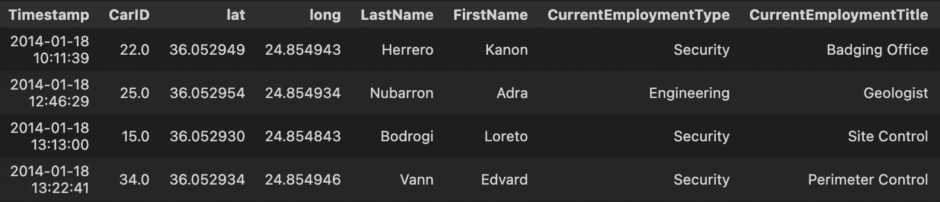

*Figure 33. Employees at the Chostus Hotel on 1/11*

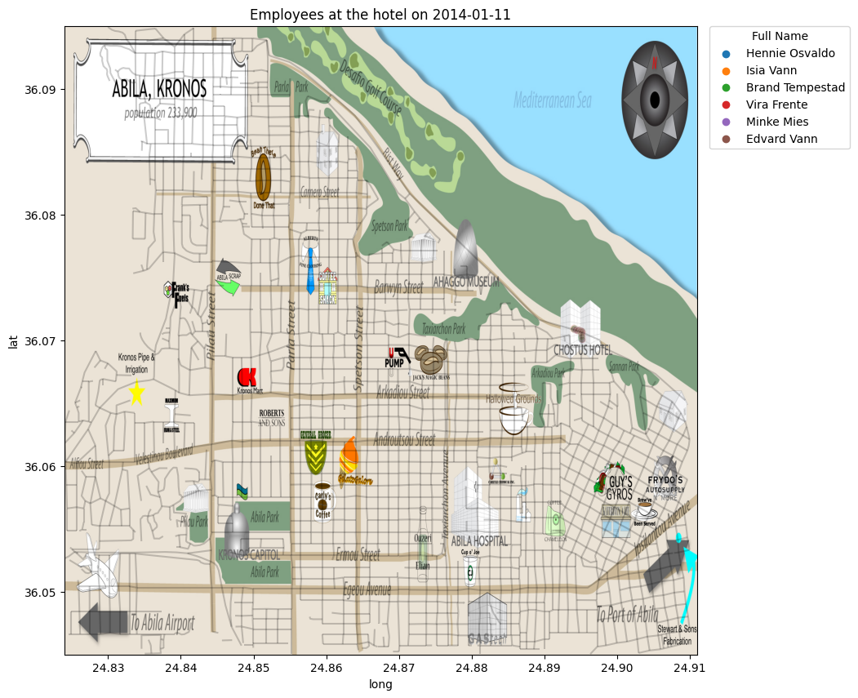

*Figure 34. Transactions at the Chostus Hotel*

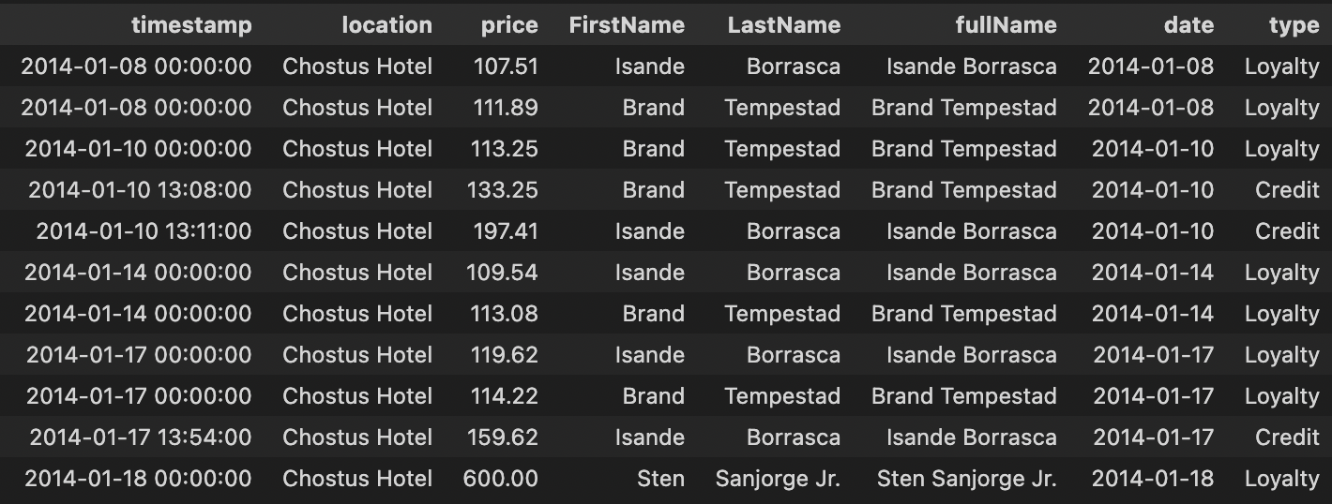

*Figure 35. GPS data for employees at Abila Scrap*

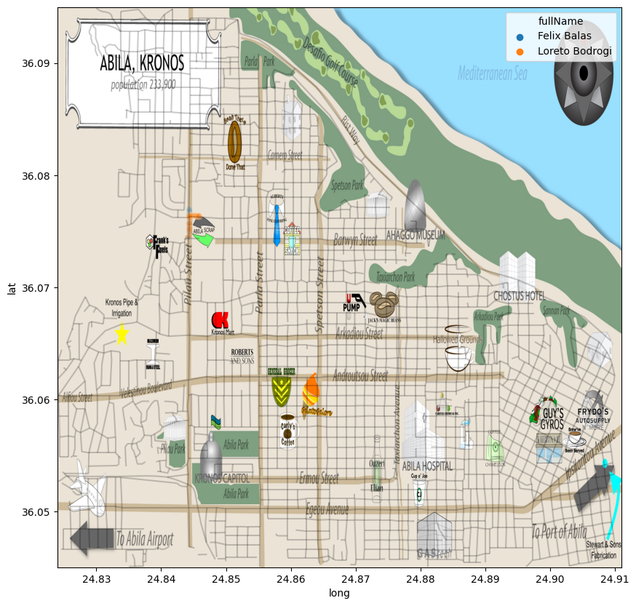

*Figure 36. Transactions at Abila Scrapyard*

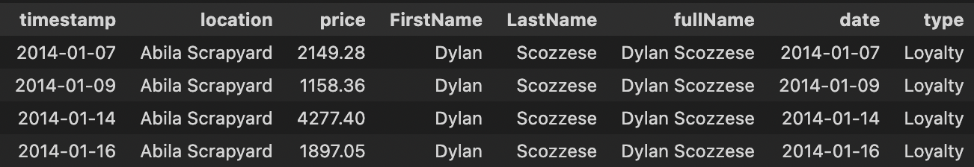

*Figure 37. Example day at Bean There Done That*

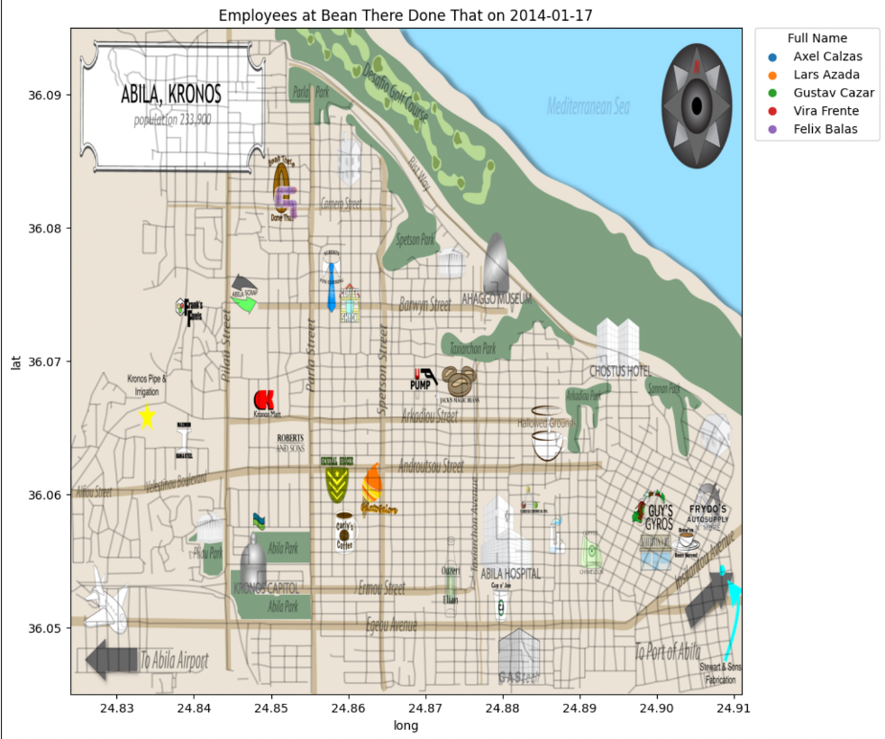

*Figure 38. GPS data of Been There Done That visits*

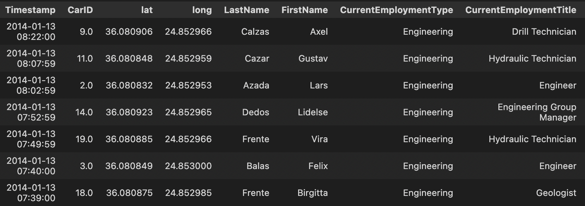

*Figure 39. Large transactions at Been There Done That*

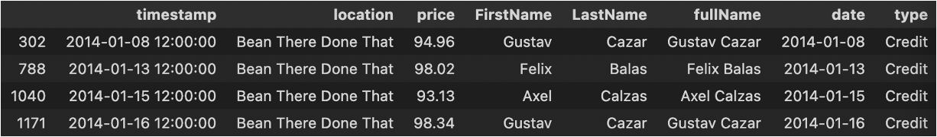

*Figure 40. Large transactions at Brew’ve Been Served*

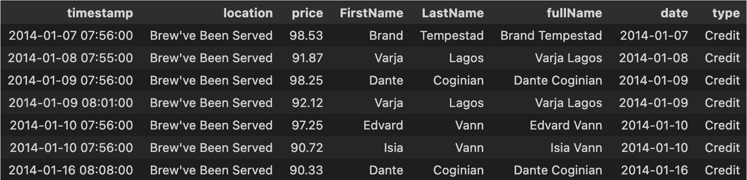

*Figure 41. Example day of traffic at Brew’ve Been Served*

*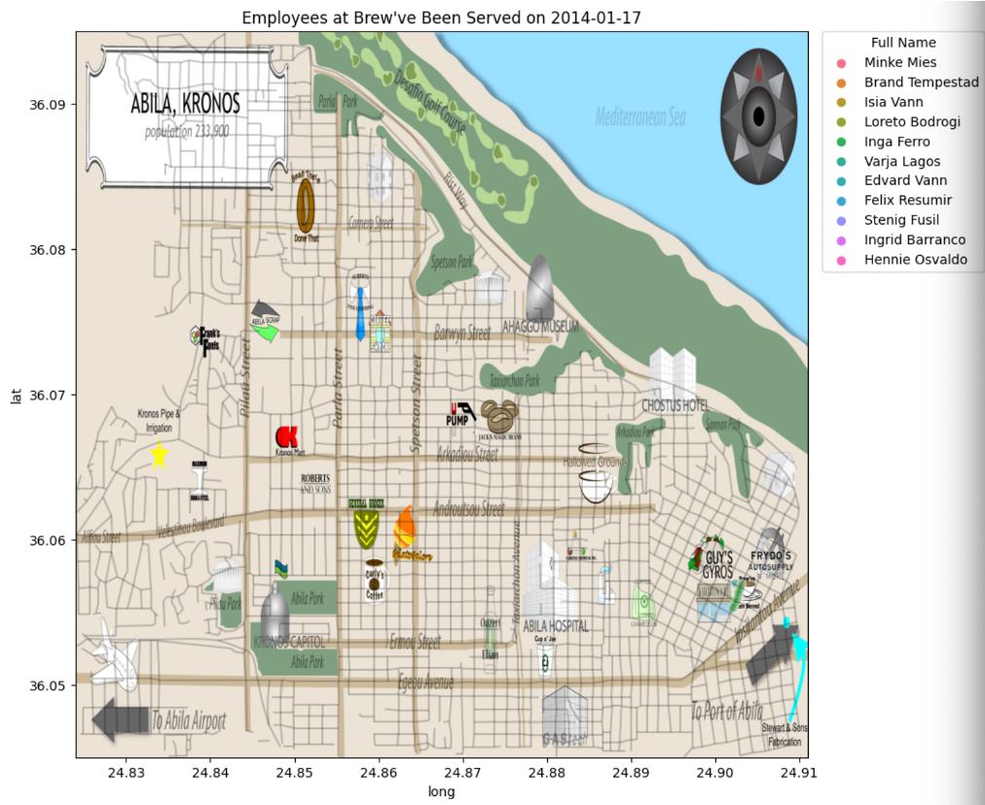Figure 42. GPS data of employees at Brew’ve Been Served*

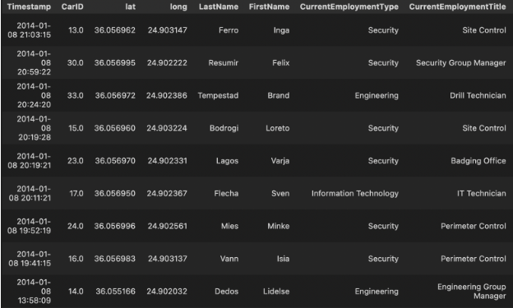

*Figure 43. Route patterns of Elsa Orilla*

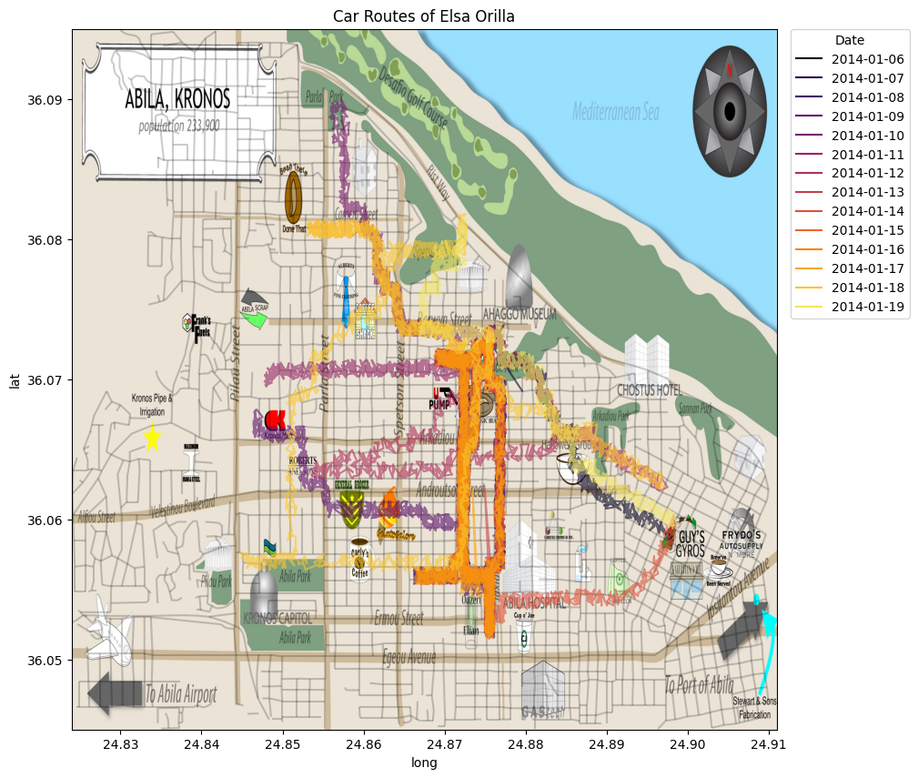

*Figure 44. Smoothed route data for Elsa Orilla*

